LECTURE NOTES ON
HYDRAULIC MACHINES &INDUSTRIA FLUID POWER LAB
For
5th SEM MechanicalEngineering (SCTE&VT Syllabus)

PREPARED BY
SANTOSH KUMAR PATRA LECTURER STAGE-1
MECHANICAL ENGINEERING



GOVERNMENT POLYTECHNIC NAYAGARH

LABORATORY MANUAL
Pr.2 — HYDRAULIC MACHINES & INDUSTRIAL FLUID POWER LAB
Diploma in Mechanical Engineering 5th Semester
Theory Periods: 4 P/W Total Period: 60
(Sessional: 25 | End Semester Exam: 50 | Total: 75)
State Council for Technical Education & Vocational Training, Odisha
Department of Mechanical Engineering
Student Name: _______________________
Roll No.: _______________________
Semester / Section: _______________________

COURSE OBJECTIVES
- Conducting performance test on impulse and reaction turbines.
- Conducting performance test on a centrifugal pump.
- Designing and operating pneumatic circuits.
- Designing and operating industrial fluid power (hydraulic) circuits.

LIST OF PRACTICALS
Sl. No. | Name of Experiment
1 | Performance test on Impulse Turbine (Pelton Wheel) and to find out the efficiency
2 | Performance test on Kaplan Turbine and to find out the efficiency
3 | Performance test on Francis Turbine and to find out the efficiency
4 | Performance test on Centrifugal Pump and to find out the characteristic curves
5 | Direct operation of single & double acting pneumatic cylinder
6 | Operating double acting pneumatic cylinder with quick exhaust valve
7 | Speed control of double acting pneumatic cylinder using metering-in and metering-out circuits
8 | Direct operation of single & double acting hydraulic cylinder
9 | Direct operation of hydraulic motor
10 | Speed control of double acting hydraulic cylinder using metering-in & metering-out circuits

EQUIPMENT LIST
Sl. No. | Name of Equipment | Quantity
1 | Impulse Turbine (Pelton Wheel) Test Rig with arrangement to find efficiency | 01 No.
2 | Kaplan Turbine Test Rig with arrangement to find efficiency | 01 No.
3 | Francis Turbine Test Rig with arrangement to find efficiency | 01 No.
4 | Centrifugal Pump Test Rig with arrangement to find efficiency | 01 No.
5 | Pneumatic Trainer Kit with accessories | 02 Nos.
6 | Hydraulic Trainer Kit with accessories | 01 No.
7 | Manual or Digital Tachometer | 05 Nos.

EXPERIMENT 1
PERFORMANCE TEST ON IMPULSE TURBINE (PELTON WHEEL)
Aim
To conduct a performance test on a Pelton wheel (impulse turbine) test rig, and to determine its efficiency at various loads / gate openings.
Apparatus Required
- Pelton wheel test rig with nozzle, spear (needle) valve, and rope-brake dynamometer loading arrangement
- Centrifugal pump with sump tank and delivery pipe to supply water to the turbine
- Venturimeter / pressure gauge at turbine inlet, tachometer, spring balances, stopwatch
Theory
A Pelton wheel is an impulse (tangential flow) turbine in which the entire pressure head of water is converted into kinetic energy in a nozzle before the jet strikes the curved buckets mounted on the periphery of the runner. Since the jet is at atmospheric pressure both before and after striking the buckets, the runner operates dry, i.e., not fully submerged, and the pressure change across the runner is zero (all the energy transfer occurs due to the change in momentum/velocity of the jet). Pelton wheels are best suited for high head, low discharge sites.
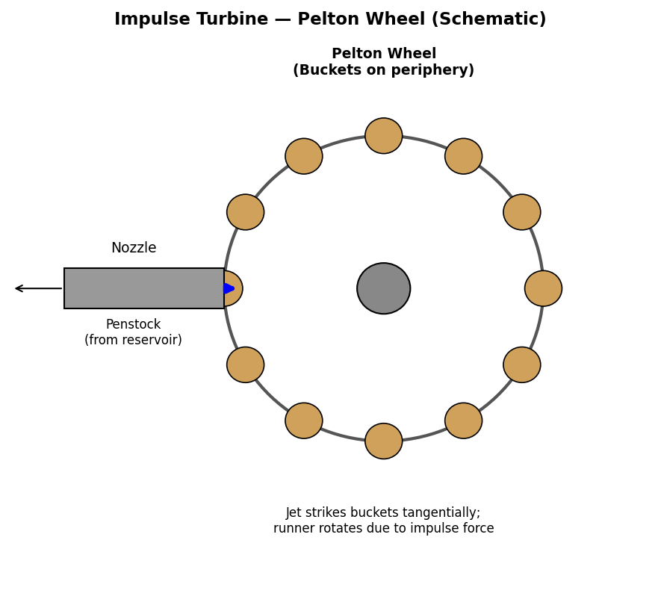
Fig. 1.1 — Impulse Turbine (Pelton Wheel) Test Rig — Schematic
Formulas
Water Power (Input), W.P. = $\frac{ρ. g . Q . H) }{1000}$ kW
Brake Power (Output), B.P. = $\frac{2×π×N×T }{60,000 }$kW, T = (W - S) x R Nm
Overall Efficiency, 𝞰= $\frac{B.P. }{W.P.}$x 100 (%)
Where: Q = Discharge (m^3/s), H = Net head available at turbine inlet (m), N = Speed of runner (rpm), T = Torque on brake drum (N-m), W = Dead weight on brake (N), S = spring balance reading (N), R = Radius of brake drum + rope (m).
Procedure
- Prime the pump and start the water supply to the turbine through the nozzle; open the spear valve fully.
- Allow the turbine to attain a steady running speed at no load.
- Gradually apply the brake load on the rope-brake dynamometer in suitable steps.
- At each load, note the speed (N) using a tachometer, the spring balance and dead-weight readings, and the discharge (Q) and head (H) at the turbine inlet.
- Repeat for a range of loads from no-load to near the maximum safe load.
- Tabulate the readings and calculate B.P., W.P. and efficiency for each load.
Observation Table
Brake drum diameter = 300 mm, Rope diameter = 15 mm, R = 0.1575 m Head, H = 20 m (approx., constant)
Sl. No. | Speed, N (rpm) | Dead Wt., W (N) | Spring Bal., S (N) | Discharge, Q (m3/s) | B.P. (kW) | W.P. (kW) | Efficiency (%)
1 | 450 | 0 | 0 | 0.010 | 0.00 | 1.962 | 0.0
2 | 420 | 20 | 5 | 0.010 | 0.463 | 1.962 | 23.6
3 | 390 | 40 | 8 | 0.010 | 0.822 | 1.962 | 41.9
4 | 350 | 60 | 12 | 0.0098 | 1.097 | 1.923 | 57.0
5 | 300 | 80 | 15 | 0.0095 | 1.072 | 1.864 | 57.5
6 | 250 | 100 | 18 | 0.0090 | 0.844 | 1.766 | 47.8
Sample Calculation (for Sl. No. 4)
Torque, T = (W - S) x R = (60 - 12) x 0.1575 = 7.56 N-m
B.P. = 2.pi.N.T / 60,000 = (2 x pi x 350 x 7.56) / 60,000 = 1.097 kW
W.P. =$ρ$.g.Q.H / 1000 = (1000 x 9.81 x 0.0098 x 20) / 1000 = 1.923 kW
Efficiency, 𝞰 = (1.097/1.923) x 100 = 57.0 %
Result
The performance test on the Pelton wheel turbine was conducted and the overall efficiency was found to vary with load, reaching a maximum of about 57.5% near the design load point. The characteristic curves of efficiency, B.P. vs. N, may be plotted from the tabulated data.
Precautions
- Ensure the water level in the sump tank is adequate before starting the pump.
- Apply and remove brake load gradually to avoid shock loading on the runner shaft.
- Take speed readings only after the turbine has reached steady-state at each load.
- Do not exceed the rated maximum load on the rope-brake dynamometer.

EXPERIMENT 2
PERFORMANCE TEST ON KAPLAN TURBINE
Aim
To conduct a performance test on a Kaplan turbine test rig and to determine its efficiency at various loads.
Apparatus Required
- Kaplan turbine test rig with adjustable guide vanes and runner blades
- Supply pump, sump tank, venturimeter/orifice meter for discharge measurement
- Rope-brake dynamometer, tachometer, pressure gauge, stopwatch
Theory
A Kaplan turbine is a low-head, high-discharge axial-flow reaction turbine in which water flows parallel to the axis of the runner. Unlike an impulse turbine, in a reaction turbine only part of the total head is converted into velocity head before the runner; the remaining pressure head is converted into kinetic energy as the water flows through the runner, so the runner must run full and there is a pressure drop across it. Kaplan turbine runners resemble a ship's propeller, with adjustable blades that allow high efficiency over a wide range of loads.
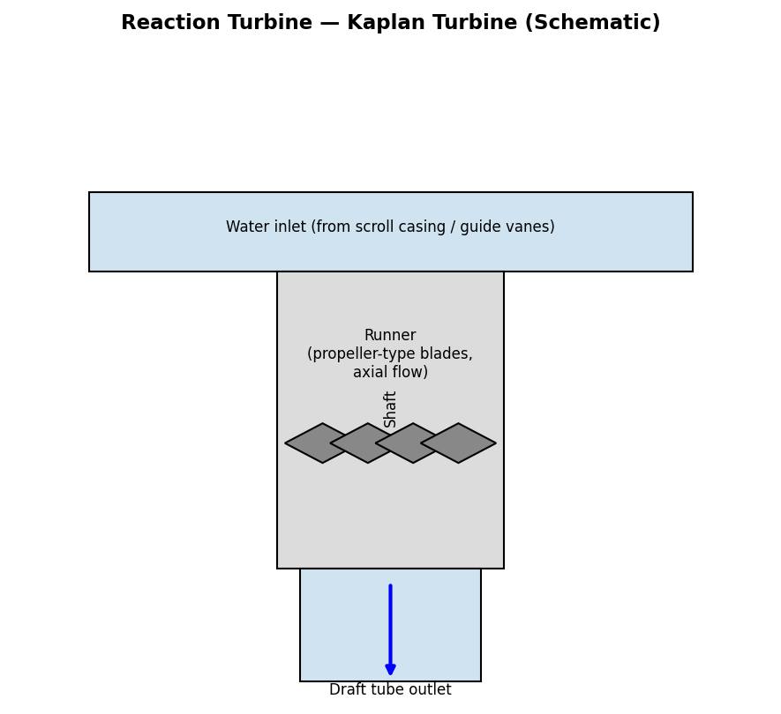
Fig. 2.1 — Kaplan Turbine (Axial Flow) Test Rig — Schematic
Formulas
Water Power, W.P. = $\frac{ρ. g . Q . H) }{1000}$ (kW)
Brake Power, B.P. = $\frac{2×π×N×T }{60,000 }$ (kW), T = (W - S).R
Overall Efficiency, 𝞰= $\frac{B.P. }{W.P.}$x 100 (%)
Symbols carry the same meaning as in Experiment 1. Since Kaplan turbines operate at low head, H is typically only a few metres in laboratory test rigs.
Procedure
- Start the supply pump and allow water to flow through the guide vanes onto the Kaplan runner.
- Adjust the guide vane opening to a fixed position and allow the turbine to attain steady speed at no load.
- Apply brake load in suitable increments using the rope-brake dynamometer.
- At each load, record speed (N), dead weight (W) and spring balance (S) readings, discharge (Q), and head (H).
- Repeat over the full range of loads and tabulate the results.
Observation Table
Brake drum radius, R = 0.15 m Head, H = 3 m (approx., constant)
Sl. No. | Speed, N (rpm) | Dead Wt., W (N) | Spring Bal., S (N) | Discharge, Q (m3/s) | B.P. (kW) | W.P. (kW) | Efficiency (%)
1 | 600 | 0 | 0 | 0.045 | 0.00 | 1.324 | 0.0
2 | 560 | 15 | 3 | 0.045 | 0.528 | 1.324 | 39.9
3 | 520 | 30 | 6 | 0.044 | 0.784 | 1.295 | 60.5
4 | 470 | 45 | 9 | 0.043 | 0.887 | 1.266 | 70.1
5 | 410 | 60 | 12 | 0.041 | 0.772 | 1.207 | 64.0
Sample Calculation (for Sl. No. 4)
Torque, T = (W-S).R = (45-9) x 0.15 = 5.4 N-m
B.P. = 2.pi.N.T/60,000 = (2 x pi x 470 x 5.4)/60,000 = 0.887 kW
W.P. = rho.g.Q.H/1000 = (1000 x 9.81 x 0.043 x 3)/1000 = 1.266 kW
Efficiency = (0.887/1.266) x 100 = 70.1 %
Result
The performance of the Kaplan turbine was evaluated; the overall efficiency reached a maximum of about 70% at moderate load, confirming the good part-load performance characteristic of Kaplan (adjustable-blade) turbines.
Precautions
- Keep the guide vane opening constant during a single test run for consistent comparison.
- Avoid sudden load changes; increase load gradually.
- Ensure the tailrace water level is maintained constant during the test.
- Check for air entrainment/cavitation noise; reduce load immediately if observed.

EXPERIMENT 3
PERFORMANCE TEST ON FRANCIS TURBINE
Aim
To conduct a performance test on a Francis turbine test rig and to determine its efficiency at various loads.
Apparatus Required
- Francis turbine test rig with scroll casing, guide vane mechanism and radial/mixed-flow runner
- Supply pump, sump tank, venturimeter for discharge measurement
- Rope-brake dynamometer, tachometer, pressure gauge, stopwatch
Theory
A Francis turbine is a medium-head, mixed-flow reaction turbine in which water enters the runner radially (through guide vanes arranged around a scroll/spiral casing) and leaves axially through a draft tube. As with all reaction turbines, only part of the head is converted to velocity head in the guide vanes; the runner works fully submerged (full of water) and a pressure drop occurs across it, with the draft tube recovering part of the kinetic energy of the water leaving the runner by allowing an increase in cross-sectional area (reducing exit velocity).
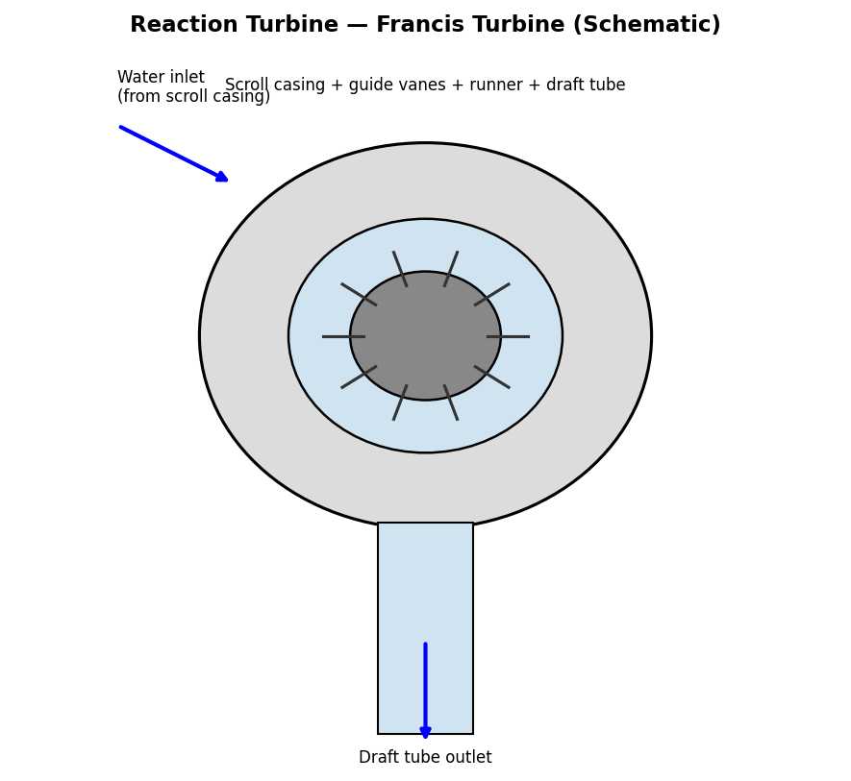
Fig. 3.1 — Francis Turbine (Mixed Flow) Test Rig — Schematic
Formulas
Water Power, W.P. = $\frac{ρ. g . Q . H) }{1000}$ (kW)
Brake Power, B.P. = $\frac{2×π×N×T }{60,000 }$ (kW), T = (W - S).R
Overall Efficiency, 𝞰= $\frac{B.P. }{W.P.}$x 100 (%)
Hydraulic Efficiency, 𝞰_{h}=$\frac{R.P. }{ W.P.}$; Mechanical Efficiency, 𝞰_{m} = B.P. / (Runner Power)
(Where Runner Power, i.e., the power actually developed by the runner before mechanical losses, may be estimated separately if instrumented; for the basic test, overall efficiency is normally reported).
Procedure
- Start the supply pump; open the guide vanes to a fixed opening and allow the runner to attain steady no-load speed.
- Apply brake load in suitable steps using the rope-brake dynamometer.
- Note the speed, dead weight, spring balance reading, discharge and head at each load step.
- Repeat for the full range of loads and tabulate results.
- Plot characteristic curves: efficiency vs. discharge/speed, B.P. vs. N, at constant head and gate opening.
Observation Table
Brake drum radius, R = 0.15 m Head, H = 6 m (approx., constant)
Sl. No. | Speed, N (rpm) | Dead Wt., W (N) | Spring Bal., S (N) | Discharge, Q (m3/s) | B.P. (kW) | W.P. (kW) | Efficiency (%)
1 | 700 | 0 | 0 | 0.028 | 0.00 | 1.648 | 0.0
2 | 650 | 20 | 4 | 0.027 | 0.817 | 1.589 | 51.4
3 | 600 | 40 | 8 | 0.026 | 1.005 | 1.530 | 65.7
4 | 540 | 60 | 12 | 0.024 | 1.221 | 1.412 | 86.5
5 | 470 | 80 | 16 | 0.022 | 1.002 | 1.295 | 77.4
Sample Calculation (for Sl. No. 4)
Torque, T = (W-S).R = (60-12) x 0.15 = 7.2 N-m
B.P. = $\frac{2×π×N×T }{60,000 }$ = $\frac{2×π×540×7.2 }{60,000 }$= 1.221 kW
W.P. = $\frac{ρ. g . Q . H) }{1000}$ = $\frac{1000 x 9.81 x 0.024 x 6 }{1000}$= 1.412 kW
Efficiency = (1.221/1.412) x 100 = 86.5 %
Result
The performance test on the Francis turbine showed a maximum overall efficiency of about 86.5% at the tested load, consistent with the generally higher efficiency of reaction turbines at their design operating point compared to impulse turbines of similar scale.
Precautions
- Ensure the draft tube remains fully primed (free of air pockets) during the test.
- Maintain constant gate opening for a given set of readings to allow valid comparison.
- Avoid abrupt load changes on the dynamometer.
- Record readings only after speed has stabilized at each load step.

EXPERIMENT 4
PERFORMANCE TEST ON CENTRIFUGAL PUMP — CHARACTERISTIC CURVES
Aim
To conduct a performance test on a centrifugal pump test rig and to draw its characteristic curves (Head vs. Discharge, Efficiency vs. Discharge, and B.P. vs. Discharge) at constant speed.
Apparatus Required
- Centrifugal pump test rig with suction and delivery pipe, pressure gauge and vacuum gauge
- Sump tank / collecting tank with measuring scale (or venturimeter) for discharge measurement
- Energy meter / wattmeter for motor input power, delivery gate valve, stopwatch
Theory
A centrifugal pump converts the mechanical (rotational) energy of a motor into hydraulic (pressure and kinetic) energy of the liquid by means of centrifugal action of a rotating impeller. Liquid enters axially near the centre (eye) of the impeller and is thrown radially outward by centrifugal force, gaining velocity; the surrounding volute casing then gradually reduces this velocity, converting kinetic energy into pressure energy at the pump outlet. Performance is usually presented as characteristic curves at a constant speed, showing how head, power and efficiency vary with discharge as the delivery valve is progressively opened (i.e., as flow resistance is reduced).
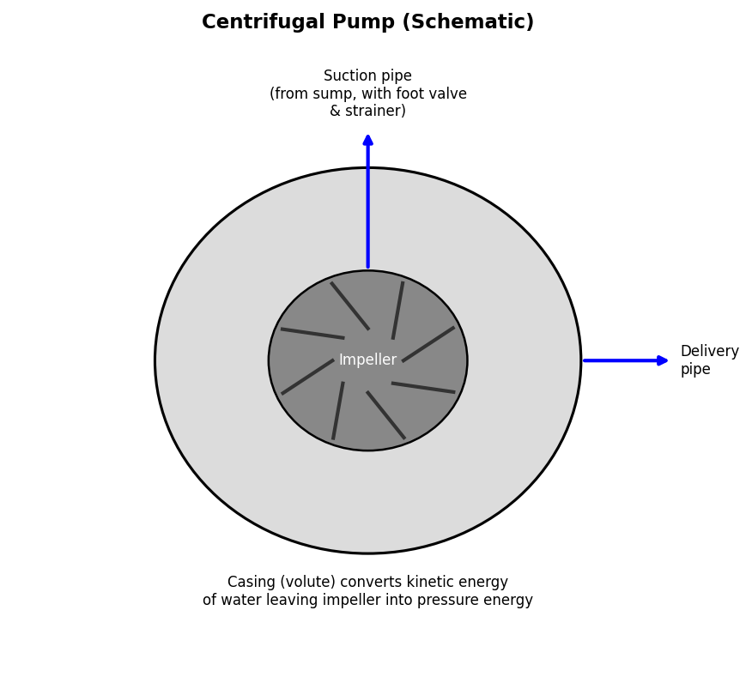
Fig. 4.1 — Centrifugal Pump Test Rig — Schematic
Formulas
Total Head, H = hd + hs + (Vd^2 - Vs^2)/2g
where hd = delivery gauge reading (converted to m of water), hs = suction gauge (vacuum) reading (m of water), Vd, Vs = velocities in delivery and suction pipe (often neglected if pipe dia. is same or gauges are close together, giving H = hd + hs approx.)
Water (Output) Power, W.P. = (𝞺.g.Q.H) / 1000 (kW)
Shaft (Input) Power, S.P. = (2.π.N.T)/60,000 kW [from motor input, or via energy meter: S.P. = motor input x motor efficiency]
Overall Efficiency of Pump,_{o} = (W.P. / S.P.) x 100 (%)
Procedure
- Prime the pump fully (fill casing and suction pipe with water, expel air) before starting.
- Start the pump with the delivery valve almost closed; then note the shut-off head (Q=0 condition).
- Gradually open the delivery valve in steps; at each valve opening, note the delivery pressure gauge and suction vacuum gauge readings.
- Measure the discharge Q at each step using the collecting tank (time to collect a known volume) or venturimeter.
- Note the motor input power at each step (using energy meter/wattmeter) or torque/speed if a dynamometer is fitted.
- Tabulate all readings and calculate H, W.P., S.P. and efficiency for each flow rate.
- Plot characteristic curves: H vs Q, eta vs Q, and S.P. vs Q on a common Q-axis.
Observation Table
Speed, N = 1440 rpm (constant, induction motor driven)
Sl. No. | Delivery Gauge (m) | Suction Gauge (m) | Total Head, H (m) | Discharge, Q (m3/s) | W.P. (kW) | S.P. (kW) | Efficiency (%)
1 | 18.0 | 1.0 | 19.0 | 0.000 | 0.00 | 0.55 | 0.0
2 | 17.0 | 1.2 | 18.2 | 0.005 | 0.893 | 0.62 | 52.4
3 | 15.5 | 1.5 | 17.0 | 0.008 | 1.334 | 0.70 | 68.6
4 | 13.0 | 1.8 | 14.8 | 0.011 | 1.597 | 0.78 | 81.4
5 | 9.5 | 2.0 | 11.5 | 0.014 | 1.579 | 0.85 | 74.1
6 | 5.0 | 2.2 | 7.2 | 0.017 | 1.201 | 0.90 | 53.4
Sample Calculation (for Sl. No. 4)
Total Head, H = 13.0 + 1.8 = 14.8 m
W.P. = rho.g.Q.H / 1000 = (1000 x 9.81 x 0.011 x 14.8)/1000 = 1.597 kW
Efficiency, eta_o = (1.597/0.78) x 100 = 81.4 %
Result
The characteristic curves of the centrifugal pump were plotted; the maximum efficiency (Best Efficiency Point, BEP) of about 81% was obtained at a discharge of approximately 0.011 m3/s, corresponding to a head of 14.8 m at the tested speed of 1440 rpm.
Precautions
- Ensure the pump is fully primed before starting to avoid running dry / air-locking.
- Do not run the pump for long with the delivery valve fully closed (risk of overheating).
- Take gauge readings only after the flow has stabilized at each valve setting.
- Check for cavitation noise; if present, reduce suction lift or note as a limiting condition.

EXPERIMENT 5
DIRECT OPERATION OF SINGLE & DOUBLE ACTING PNEUMATIC CYLINDER
Aim
To design and operate pneumatic circuits for the direct control of (i) a single-acting cylinder using a 3/2 DCV, and (ii) a double-acting cylinder using a 5/2 DCV, and to study their working and timing characteristics.
Apparatus Required
- Pneumatic trainer kit with FRL (Filter-Regulator-Lubricator) unit, air compressor / air supply
- Single-acting cylinder, Double-acting cylinder
- 3/2 Direction Control Valve (push-button, spring return), 5/2 Direction Control Valve
- Pneumatic hoses/tubing, pressure gauge, stopwatch
Theory
A single-acting cylinder is extended by compressed air on one side of the piston only; retraction occurs by a spring or by the external load/gravity once the air supply is cut off (and the cylinder exhausted) — hence it requires only a single air connection and is controlled by a 3-port, 2-position (3/2) DCV. A double-acting cylinder receives compressed air alternately on both sides of the piston for both extension and retraction strokes, giving power in both directions; it therefore needs two air connections and is typically controlled by a 5-port, 2-position (5/2) DCV, which alternately connects one port to pressure and the other to exhaust.
5(a) Single-Acting Cylinder Circuit
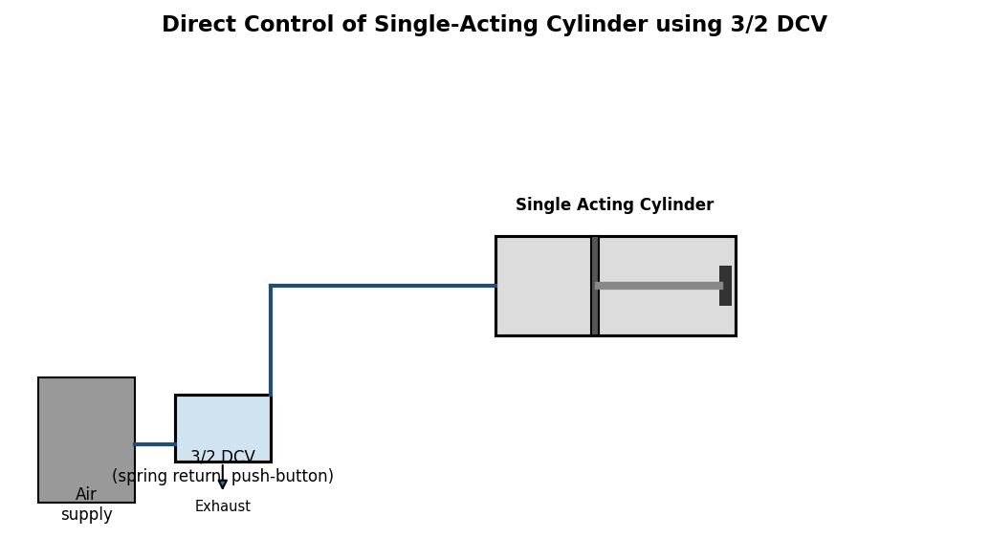
Fig. 5.1 — Direct control of a single-acting cylinder using a 3/2 DCV
When the push-button of the 3/2 DCV is pressed, compressed air flows to the cylinder, extending the piston. On release, the valve spring returns it to the initial position, cutting off supply and connecting the cylinder port to exhaust; the cylinder's internal spring then retracts the piston.
5(b) Double-Acting Cylinder Circuit
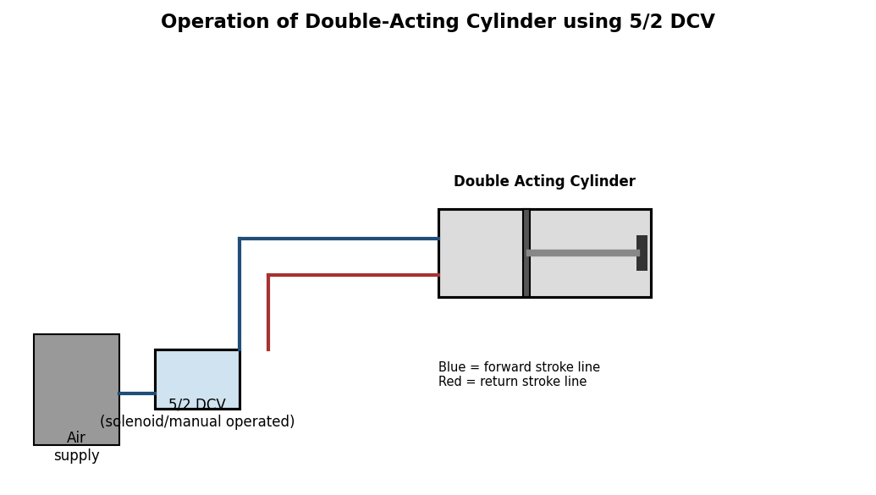
Fig. 5.2 — Operation of a double-acting cylinder using a 5/2 DCV
Actuating the 5/2 DCV in one position connects compressed air to the rear (cap) end of the cylinder and the front (rod) end to exhaust, extending the piston. Reversing the valve connects air to the front end and exhausts the rear end, retracting the piston. Both strokes are power strokes.
Formula — Cylinder Force
Extension Force, F_ext = p x (π/4) x D²
Retraction Force, F_ret = p x (π /4) x (D² - d²) [double-acting, accounting for piston rod area]
where p = supply air pressure (N/mm^2 or bar converted appropriately), D = piston (bore) diameter, d = piston rod diameter.
Procedure
- Connect the FRL unit to the air supply; set the working pressure using the pressure regulator (e.g., 5-6 bar).
- For the single-acting circuit: connect the compressor outlet -> FRL -> 3/2 DCV -> single-acting cylinder port; operate the push-button and observe extension; release and observe spring-return retraction.
- For the double-acting circuit: connect FRL -> 5/2 DCV -> both ports of the double-acting cylinder; actuate the valve manually/electrically in each direction and observe both power strokes.
- Measure the time taken for full extension and full retraction using a stopwatch at the set pressure.
- Repeat at 2-3 different supply pressures and tabulate the stroke times and calculated forces.
Observation Table
Cylinder bore, D = 32 mm, Rod diameter, d = 12 mm, Stroke length = 100 mm
Sl. No. | Supply Pressure (bar) | Type | Extension Time (s) | Retraction Time (s) | Extension Force (N) | Retraction Force (N)
1 | 4 | Single-acting | 0.62 | 0.45 | 322 | -
2 | 6 | Single-acting | 0.41 | 0.30 | 483 | -
3 | 4 | Double-acting | 0.35 | 0.38 | 322 | 277
4 | 6 | Double-acting | 0.24 | 0.26 | 483 | 415
Sample Calculation (Sl. No. 4, Double-acting, extension)
p = 6 bar = 0.6 N/mm^2; D = 32 mm
F_ext = p x (π/4) x D² = 0.6 x (π/4) x 32^2 = 0.6 x 804.25 = 482.5 N (approx. 483 N)
F_ret = p x (π/4) x (D^{^2} - d^{^2}) = 0.6 x (π/4) x (1024-144) = 0.6 x 691.15 = 414.7 N
Result
The single-acting and double-acting pneumatic cylinder circuits were successfully designed, connected and operated. The cylinder stroke time was found to decrease (i.e., speed increases) with increase in supply pressure, and the theoretical forces matched the trend of the observed cylinder performance.
Precautions
- Do not exceed the rated working pressure of the trainer kit / cylinder.
- Ensure all quick-connect fittings are properly seated before pressurizing the circuit.
- Keep hands clear of the cylinder rod during operation to avoid pinch injury.
- Depressurize the circuit fully before disconnecting hoses.

EXPERIMENT 6
OPERATING DOUBLE ACTING PNEUMATIC CYLINDER WITH QUICK EXHAUST VALVE
Aim
To design and operate a pneumatic circuit incorporating a Quick Exhaust Valve (QEV) for rapid retraction (or extension) of a double-acting cylinder, and to compare cylinder speed with and without the QEV.
Apparatus Required
- Pneumatic trainer kit with FRL unit and air supply
- Double-acting cylinder, 5/2 DCV
- Quick Exhaust Valve (QEV), pneumatic hoses, stopwatch
Theory
A Quick Exhaust Valve is a 3-port valve fitted directly at (or very close to) a cylinder port. It allows air to flow freely from the DCV to the cylinder in the normal direction, but when the cylinder port pressure exceeds the supply-side pressure (i.e., during the exhaust stroke), the QEV's internal disc shifts and opens a large direct exhaust port to atmosphere right at the cylinder — bypassing the long return path through the DCV and its narrow internal passages/tubing. This significantly reduces the exhaust flow restriction and produces a much faster piston stroke than exhausting air all the way back through the DCV.
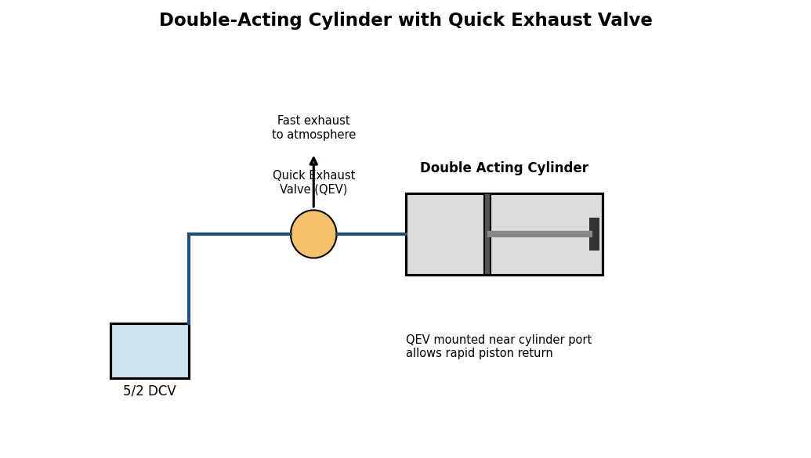
Fig. 6.1 — Double-acting cylinder circuit with a Quick Exhaust Valve for rapid return stroke
Procedure
- Set up the base double-acting cylinder circuit with the 5/2 DCV as in Experiment 5(b); record the normal retraction time (without QEV).
- Install the QEV directly at the cylinder port for the stroke to be made rapid (commonly the retraction/return port), with its exhaust port left open to atmosphere (fit a silencer if available).
- Reconnect the DCV-to-cylinder line through the QEV's inlet and cylinder-side port.
- Operate the DCV to extend and retract the cylinder; measure and record the new (faster) stroke time with the QEV fitted.
- Repeat at 2-3 supply pressures and tabulate a comparison of stroke times with and without the QEV.
Observation Table
Cylinder bore = 32 mm, Stroke = 100 mm, Supply pressure = 5 bar (constant)
Sl. No. | Condition | Extension Time (s) | Retraction Time (s) | % Reduction in Retraction Time
1 | Without QEV (through DCV only) | 0.30 | 0.34 | —
2 | With QEV at retraction port | 0.30 | 0.12 | 64.7 %
Sample Calculation
% Reduction in retraction time = [(0.34 - 0.12) / 0.34] x 100 = (0.22/0.34) x 100 = 64.7 %
Result
The Quick Exhaust Valve circuit was successfully implemented; the retraction (return stroke) time of the double-acting cylinder was reduced by about 65% compared to normal operation through the DCV alone, demonstrating the effectiveness of a QEV for high-speed cylinder applications (e.g., stamping, ejection operations).
Precautions
- Mount the QEV as close as possible to the cylinder port for maximum benefit.
- Ensure the QEV's exhaust port is unobstructed and fitted with a silencer to control noise.
- Be cautious of the increased piston speed — keep hands and loose items clear of the cylinder stroke path.
- Check that the QEV is correctly oriented (inlet/outlet/exhaust) as per its data-plate markings.

EXPERIMENT 7
SPEED CONTROL OF DOUBLE ACTING PNEUMATIC CYLINDER — METERING-IN AND METERING-OUT CIRCUITS
Aim
To design and operate metering-in and metering-out flow control circuits for speed control of a double-acting pneumatic cylinder, and to compare the smoothness and controllability of piston motion in each case.
Apparatus Required
- Pneumatic trainer kit with FRL unit, air supply
- Double-acting cylinder, 5/2 DCV
- Two flow control (throttle/one-way flow control) valves, hoses, stopwatch
Theory
Flow control valves are used to regulate the speed of a pneumatic cylinder by restricting (metering) the flow of air. Two basic arrangements exist:
- Meter-in circuit: the flow control valve restricts the air flowing INTO the cylinder (on the supply/inlet side); speed is controlled by limiting how quickly air can enter and push the piston.
- Meter-out circuit: the flow control valve restricts the air flowing OUT of the cylinder (on the exhaust side), i.e., the cylinder is allowed to fill quickly but its exhaust air is metered, creating a back-pressure that resists and smooths the piston's motion.
For pneumatic systems (air being compressible), meter-out control is generally preferred and gives smoother, more stable speed control than meter-in, because the trapped back-pressure on the exhaust side resists sudden movement, whereas meter-in can lead to jerky/uneven motion since the (compressible) air ahead of the piston offers little resistance once compressed. (Note: for hydraulic — incompressible fluid — meter-out control on the outlet is similarly preferred to prevent overrunning loads.)
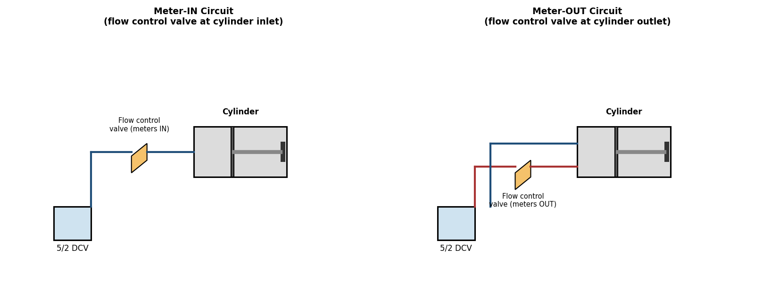
Fig. 7.1 — Meter-IN circuit (left) vs. Meter-OUT circuit (right) for cylinder speed control
Procedure
- Meter-in circuit: Connect a one-way flow control valve at the cylinder's inlet port, oriented so that it restricts flow entering the cylinder (free flow allowed on exhaust). Operate the DCV and adjust the flow control valve knob through several settings, timing the extension stroke at each setting.
- Meter-out circuit: Reverse the flow control valve orientation (or move it to the exhaust port) so that it restricts flow leaving the cylinder (free flow allowed on the inlet). Repeat the timing test at the same valve settings.
- Observe and note the smoothness of piston motion (steady vs. jerky) in each configuration.
- Tabulate stroke time vs. flow control valve opening for both circuits and compare.
Observation Table
Cylinder bore = 32 mm, Stroke = 100 mm, Supply pressure = 5 bar
Sl. No. | Valve Opening (turns from closed) | Extension Time — Meter-IN (s) | Extension Time — Meter-OUT (s) | Remarks (motion quality)
1 | 1 (nearly closed) | 2.10 | 2.35 | Meter-IN: slightly jerky start
2 | 2 | 1.05 | 1.20 | Meter-OUT smoother
3 | 3 | 0.55 | 0.68 | Meter-OUT smoother
4 | Fully open | 0.30 | 0.32 | Comparable at full open
Result
Both meter-in and meter-out flow control circuits were successfully set up and tested. It was observed that for the same valve opening, the meter-out circuit provided a smoother and more controllable/uniform piston speed, particularly at low flow settings, confirming meter-out as the generally preferred method of speed control for pneumatic (and hydraulic) cylinders.
Precautions
- Adjust flow control valves gradually while observing cylinder motion to avoid sudden jerks.
- Ensure the one-way (check valve) function of the flow control valve is oriented correctly for the intended metering direction.
- Do not fully close the flow control valve while the system is pressurized and the cylinder is mid-stroke to avoid pressure lock.
- Record stroke times only after the circuit has reached consistent, repeatable operation.

EXPERIMENT 8
DIRECT OPERATION OF SINGLE & DOUBLE ACTING HYDRAULIC CYLINDER
Aim
To design and operate hydraulic circuits for the direct control of a single-acting and a double-acting hydraulic cylinder, and to study their working.
Apparatus Required
- Hydraulic trainer kit with motor-driven gear pump, reservoir, pressure relief valve
- Single-acting hydraulic cylinder, Double-acting hydraulic cylinder
- 4/3 or 4/2 Direction Control Valve (manually/lever operated)
- Hydraulic hoses, pressure gauge, stopwatch
Theory
Hydraulic circuits operate on the same basic principles as pneumatic circuits, but use an (essentially incompressible) hydraulic oil instead of compressed air, pressurized by a motor-driven pump rather than a compressor, and always require a return line back to the reservoir (unlike pneumatics, which typically exhausts to atmosphere). Because oil is incompressible, hydraulic cylinders give much stiffer, more precise and higher-force actuation than pneumatic cylinders of similar size, but require a closed-loop circuit (pump - valve - actuator - reservoir) and a pressure relief valve to protect the system from over-pressure.
A single-acting hydraulic cylinder is extended by pump pressure and retracted by gravity/spring/external load, needing only one hydraulic line (plus a vented or connected return for the rod side). A double-acting hydraulic cylinder is powered in both directions, requiring a 4-way (4/2 or 4/3) DCV that alternately directs pump flow to each side of the piston while connecting the opposite side back to the reservoir (tank line).
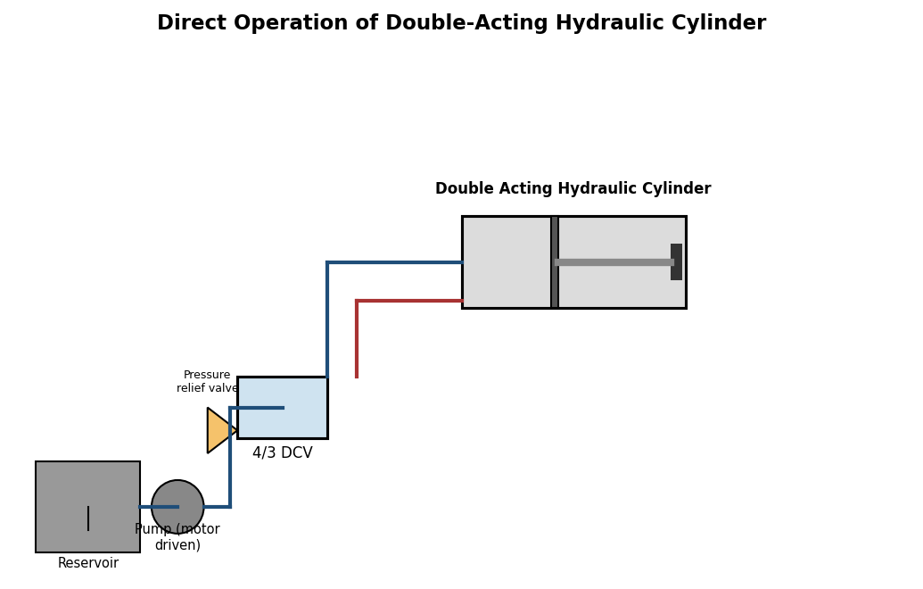
Fig. 8.1 — Circuit for direct operation of a double-acting hydraulic cylinder
Formula — Cylinder Force and Speed
Force, F = p x (π/4) x D2 (extension);
F = p x (π /4) x (D² - d²) (retraction, rod side)
Piston Speed, v = Q / A (Q = pump flow rate to cylinder, A = effective piston area)
where p = system (relief valve set) pressure, D = bore diameter, d = rod diameter, Q = flow rate delivered by the pump to the cylinder.
Procedure
- Check oil level in the reservoir; bleed air from the circuit before starting the pump.
- Set the pressure relief valve to the required working pressure (e.g., 30-50 bar depending on trainer rating).
- Connect the pump outlet -> DCV -> single-acting cylinder for the first part; operate the DCV lever and observe extension (pump pressure) and retraction (by gravity/spring, oil returning to tank).
- Reconfigure/connect the DCV to both ports of the double-acting cylinder; operate the lever in both directions and observe powered extension and retraction.
- Measure the stroke time for extension and retraction using a stopwatch at a given pump flow/pressure setting.
- Tabulate observations and compute theoretical force and speed for comparison.
Observation Table
Cylinder bore, D = 40 mm, Rod diameter, d = 18 mm, Stroke = 150 mm, Pump flow, Q = 8 lpm
Sl. No. | System Pressure (bar) | Type | Extension Time (s) | Retraction Time (s) | Extension Force (N)
1 | 20 | Single-acting | 1.25 | 0.90 (gravity) | 2513
2 | 30 | Double-acting | 1.20 | 1.55 | 3770
3 | 40 | Double-acting | 1.20 | 1.55 | 5027
Sample Calculation (Sl. No. 3, extension)
p = 40 bar = 4.0 N/mm²; D = 40 mm
F = p x (π/4) x D²= 4.0 x (π/4) x 1600 = 4.0 x 1256.6 = 5026.5 N (approx. 5027 N)
Piston speed (theoretical), v = Q/A = (8x10⁻³/60) / (1256.6x10⁻⁶) = 1.333x10⁻⁴/1.2566x10⁻³ = 0.106 m/s
Extension time (theoretical) = Stroke/v = 0.150/0.106 = 1.42 s (close to observed 1.20 s, difference due to valve/line losses)
Result
The single-acting and double-acting hydraulic cylinder circuits were successfully designed and operated. The observed extension force increased proportionally with system pressure, consistent with the theoretical relation F = p.A.
Precautions
- Bleed all trapped air from the hydraulic lines before operation to avoid spongy/erratic cylinder motion.
- Never exceed the set relief valve pressure or the rated pressure of hoses/fittings.
- Check for oil leaks at all connections before and during the test.
- Keep hands clear of the cylinder rod and any pinch points during operation.

EXPERIMENT 9
DIRECT OPERATION OF HYDRAULIC MOTOR
Aim
To design and operate a hydraulic circuit for the direct operation of a hydraulic motor, and to study the relationship between pump flow rate, motor speed and output torque.
Apparatus Required
- Hydraulic trainer kit with motor-driven gear pump, reservoir, pressure relief valve
- Hydraulic (gear/vane) motor with output shaft
- 4/3 DCV, pressure gauge, tachometer, simple brake/loading arrangement, stopwatch
Theory
A hydraulic motor is the rotary counterpart of a hydraulic cylinder — it converts hydraulic (fluid) power into continuous rotary mechanical power, essentially operating as a pump in reverse. Pressurized oil delivered by the pump acts on the motor's internal gears/vanes/pistons, producing an output torque and rotating the motor shaft; oil returning from the motor flows back to the reservoir through the DCV. Hydraulic motors are widely used where compact, high-torque, variable-speed rotary drives are required (e.g., winches, conveyor drives, construction machinery).
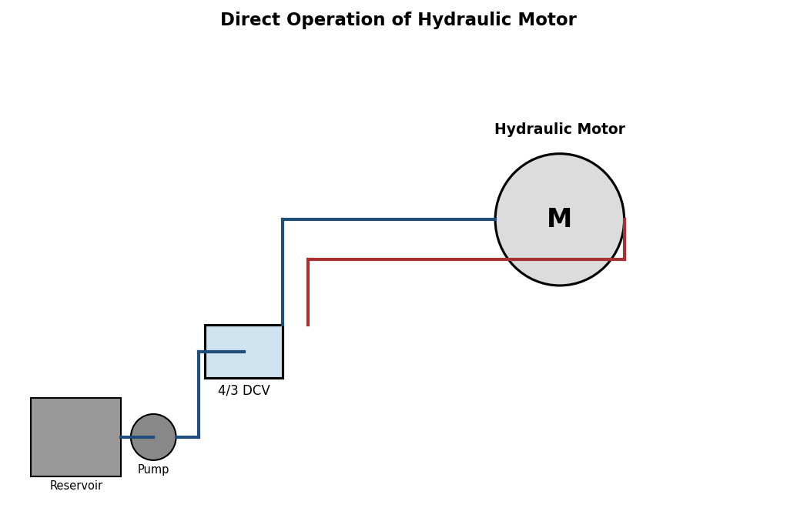
Fig. 9.1 — Circuit for direct operation of a hydraulic motor
Formulas
Theoretical Speed, N = Q / Vd (rpm, if Q in consistent volumetric units per revolution)
Torque, T = (p x Vd) / (2.π) (N-m)
Hydraulic Power Input = p.Q/600 (kW, p in bar, Q in lpm); Output (Shaft) Power = 2.π.N.T/60,000 (kW)
Volumetric Efficiency, eta_v = N_actual / N_theoretical; Mechanical Efficiency, eta_m = Output Power / Hydraulic Power Input
where Q = pump flow rate to motor, Vd = motor displacement (volume per revolution), p = operating pressure, N = motor speed.
Procedure
- Connect the pump outlet through the DCV to the hydraulic motor's inlet port, with the motor's outlet connected back to the reservoir through the DCV's return line.
- Start the pump and actuate the DCV to direct flow to the motor; observe the motor shaft begin to rotate.
- Measure the motor speed using a tachometer at a given pump flow setting/pressure.
- Apply a small brake load (if a loading arrangement is fitted) and note the corresponding drop in speed and rise in pressure.
- Repeat at 2-3 flow/pressure settings and tabulate speed, pressure and calculated torque/power.
Observation Table
Motor displacement, Vd = 15 cc/rev, Pump flow, Q = 6 lpm (approx., adjustable)
Sl. No. | Pressure, p (bar) | Flow, Q (lpm) | Motor Speed, N (rpm) | Torque, T (N-m) | Output Power (kW)
1 | 15 | 6 | 380 | 3.58 | 0.142
2 | 25 | 6 | 370 | 5.97 | 0.231
3 | 35 | 6 | 355 | 8.35 | 0.310
Sample Calculation (Sl. No. 3)
T = (p.Vd)/(2.π) = (35x10^5 x 15x10^-6) / (2.π) = 52.5 / 6.283 = 8.35 N-m
Output Power = 2.π.N.T/60,000 = (2 x πx 355 x 8.35)/60,000 = 0.310 kW
Result
The hydraulic motor circuit was successfully designed and operated. The motor output torque was found to increase with system pressure, while speed decreased slightly with increasing load pressure (due to internal leakage effects), consistent with expected hydraulic motor behavior.
Precautions
- Do not exceed the rated pressure or speed of the hydraulic motor.
- Apply braking load gradually; avoid stalling the motor under full pump pressure for extended periods.
- Ensure proper alignment of the motor shaft with any coupled load/brake to avoid vibration.
- Monitor oil temperature; stop the test if excessive heating is observed.

EXPERIMENT 10
SPEED CONTROL OF DOUBLE ACTING HYDRAULIC CYLINDER — METERING-IN & METERING-OUT CIRCUITS
Aim
To design and operate metering-in and metering-out flow control circuits for speed control of a double-acting hydraulic cylinder, and to study cylinder speed and stability (resistance to load-induced overrun) in each case.
Apparatus Required
- Hydraulic trainer kit with pump, reservoir, pressure relief valve
- Double-acting hydraulic cylinder, 4/3 DCV
- Two adjustable flow control valves (with integral check valve for one-way metering), hoses, stopwatch
Theory
As with pneumatic circuits, hydraulic cylinder speed can be controlled by restricting oil flow either into the cylinder (meter-in) or out of the cylinder (meter-out). Since hydraulic oil is virtually incompressible, meter-in control works reasonably well for resistive (opposing) loads, but for overrunning loads (where the load tends to pull/push the piston faster than the metered inlet flow, e.g., a vertical cylinder lowering a weight) a meter-in circuit can allow the cylinder to cavitate or run away, since the exhaust side offers little resistance. A meter-out circuit, which restricts oil leaving the cylinder, maintains a back-pressure on the outlet side at all times, positively controlling the piston speed regardless of whether the load resists or assists motion — this makes meter-out the generally preferred method for hydraulic cylinder speed control, particularly for overrunning/vertical loads.
Procedure
- Meter-in circuit: Fit a one-way flow control valve at the cylinder's inlet port, oriented to restrict incoming flow (free reverse flow through the check valve on the return). Operate the DCV, and time the extension stroke at several valve settings.
- Meter-out circuit: Reposition/reorient the flow control valve to restrict the oil leaving the cylinder on the working stroke instead. Repeat the timed test at the same settings.
- For each circuit, additionally test with a light external load resisting and then assisting the piston motion (if the trainer permits), and note the smoothness/stability of motion.
- Tabulate stroke times and qualitative stability observations for both circuits.
Observation Table
Cylinder bore = 40 mm, Stroke = 150 mm, System pressure = 30 bar
Sl. No. | Flow Control Setting | Extension Time — Meter-IN (s) | Extension Time — Meter-OUT (s) | Remarks
1 | 1/4 open | 4.20 | 4.65 | Meter-IN: mild surge at start under assisting load
2 | 1/2 open | 2.10 | 2.35 | Meter-OUT: smooth, stable in both load directions
3 | Fully open | 1.20 | 1.25 | Comparable; minimal difference at full open
Result
Both meter-in and meter-out hydraulic speed-control circuits were designed and successfully tested. As with the pneumatic case, the meter-out arrangement provided more stable and controllable piston speed — particularly under assisting (overrunning) load conditions — confirming it as the preferred method for hydraulic cylinder speed control in practical applications.
Precautions
- Adjust the flow control valve gradually; sudden fully-closed settings can cause a hydraulic pressure spike.
- Ensure the relief valve is correctly set to protect the circuit from over-pressure at low flow settings.
- Check for and bleed any trapped air, which can make speed control appear erratic.
- Do not leave the system pressurized with the DCV in a blocked/dead-head position for extended periods.

