LECTURE NOTES ON
MATERIAL TESTING AND METALLOGRAPHY LAB

3rd SEM Mechanical Engineering (SCTE&VT Syllabus)

PREPARED BY

SANTOSH KUMAR PATRA LECTURER STAGE-1
MECHANICAL ENGINEERING



GOVERNMENT POLYTECHNIC NAYAGARH

LABORATORY MANUAL

PR: 2 MATERIAL TESTING AND METALLOGRAPHY LAB
Course Code: MEPC213
L-T-P: 0-0-4 Credit: 2 Total Marks: 50
(End Term Exam: 15 | Progressive Assessment: 35)
Department of Mechanical Engineering
Student Name: _______________________
Roll No.: _______________________
Semester / Section: _____________________

RATIONALE
Material Testing and Metallography Lab helps students understand the mechanical properties of materials through tests like hardness, tensile, and impact testing. It also provides hands-on experience in metallographic techniques for analysing microstructures, ensuring quality control in engineering applications.

LEARNING OUTCOMES
- To identify the type of material based on its grain structure.
- To learn the procedure for identifying cracks in a material.
- To illustrate various material testing methods to determine mechanical properties such as yield stress, ultimate stress, percentage elongation, Young's Modulus, etc.

LIST OF EXPERIMENTS
Sl. No. | Name of Experiment
I | Preparation of a specimen and examination of microstructure of Ferrous and Non-ferrous metals using the Metallurgical Microscope
II | Detection of cracks by (i) Visual & Ring test (ii) Dye Penetrant Test (iii) Magnetic Particle Test
III | Determination of Rockwell Hardness Number for Mild Steel, High Carbon Steel, Brass, Copper and Aluminium
IV | Izod and Charpy Impact Test
V | Torsion Test on Mild Steel
VI | Tensile Test — Young's Modulus, Yield Point, % Elongation and % Reduction in Area on Mild Steel
VII | Modulus of Rigidity, Strain Energy and Stiffness by Load-Deflection Method (Open & Closed Coil Spring)
VIII | Single and Double Shear Test on M.S. Bar

EXPERIMENT I
MICROSTRUCTURE EXAMINATION OF FERROUS AND NON-FERROUS METALS
Aim
To prepare a metallographic specimen and examine the microstructure of a given ferrous metal (mild steel) and a non-ferrous metal (brass) using a Metallurgical Microscope.
Apparatus / Specimens Required
- Metallurgical (optical) microscope with camera attachment
- Mild steel and brass specimens
- Belt/disc polishing machine, emery papers (grade 1/0 to 4/0)
- Double disc polishing machine with velvet cloth and alumina/diamond paste
- Etchants: 2% Nital (for steel), Ferric chloride solution (for brass)
- Mounting press (bakelite powder) or cold mount resin, hot air drier
Theory
Metallography is the study of the physical structure and components of metals, typically using microscopy. The microstructure of a metal (grain size, shape, phase distribution) is directly related to its mechanical properties such as strength, ductility, hardness and toughness. Ferrous alloys such as mild steel show ferrite (bright, soft phase) and pearlite (lamellar mixture of ferrite and cementite) grains, while non-ferrous alloys such as brass show equiaxed alpha grains with characteristic annealing twin lines. Since metals are opaque, the microstructure is revealed under reflected light after polishing to a mirror finish and etching with a suitable reagent that attacks grain boundaries selectively.
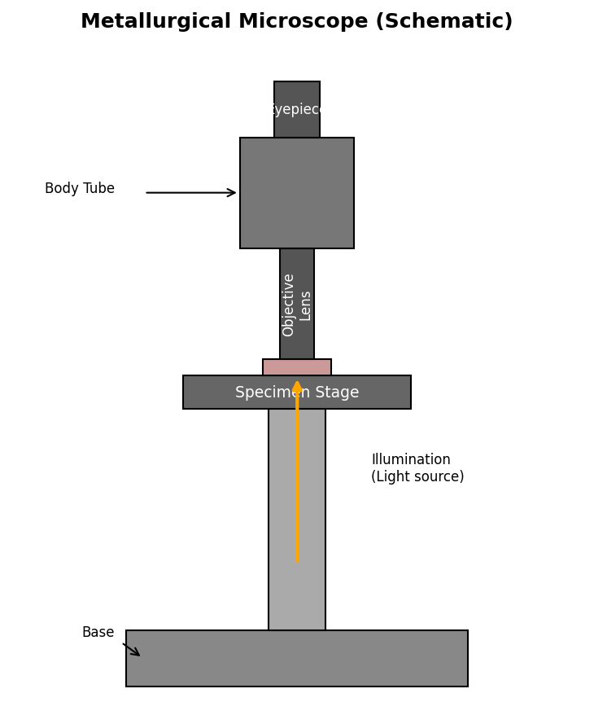
Fig. 1.1 — Metallurgical Microscope (Schematic)
Procedure (Specimen Preparation)
- Sectioning: Cut a small specimen (~15 mm x 15 mm) from the given sample using a power hacksaw/abrasive cutter, avoiding overheating.
- Mounting: Mount the specimen in bakelite powder using a hot mounting press for ease of handling (cold resin mounting may also be used).
- Rough grinding: Grind the mounted specimen on successively finer emery papers (1/0 → 4/0), rotating specimen 90° between grades and washing between stages.
- Polishing: Polish on a rotating disc using alumina or diamond paste with water/lubricant until a mirror-like, scratch-free surface is obtained.
- Cleaning: Wash with water, rinse with alcohol and dry with hot air.
- Etching: Immerse the polished surface in the appropriate etchant for a few seconds (2% Nital for steel, FeCl3 solution for brass), then wash and dry immediately.
- Examination: Place the specimen on the microscope stage and observe the microstructure under increasing magnifications (100X, 400X). Capture/sketch the observed grain structure.
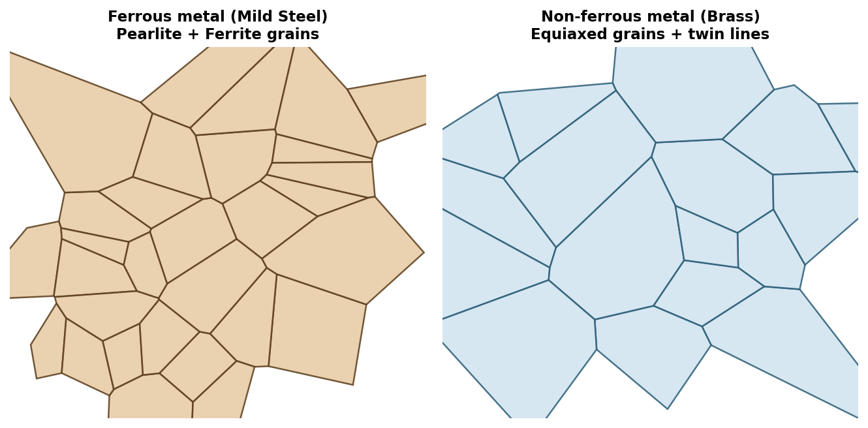
Fig. 1.2 — Typical microstructures: (a) Mild Steel — Ferrite + Pearlite (b) Brass — Equiaxed grains with annealing twins
Observation Table
Sl. No. | Specimen | Etchant Used | Etching Time (s) | Magnification | Observed Structure
1 | Mild Steel (Ferrous) | 2% Nital | 8 | 100X | Ferrite (white) + Pearlite (dark, lamellar)
2 | Brass (Non-ferrous) | FeCl3 solution | 12 | 100X | Equiaxed alpha grains with twin bands
Result
The microstructures of the given ferrous (mild steel) and non-ferrous (brass) specimens were successfully examined. Mild steel showed a ferrite–pearlite structure typical of a low-carbon steel, while brass showed equiaxed grains with annealing twins, confirming the material type from its grain morphology.
Precautions
- Avoid overheating the specimen during cutting/grinding to prevent microstructural changes.
- Rotate the specimen 90° between successive grades of emery paper and clean thoroughly to avoid carrying coarse grit forward.
- Do not over-etch; a lightly etched surface reveals grain boundaries better than a heavily etched one.
- Handle etchants (Nital, FeCl3) with gloves in a fume hood.

EXPERIMENT II
DETECTION OF CRACKS — VISUAL/RING TEST, DYE PENETRANT TEST & MAGNETIC PARTICLE TEST
Aim
To detect surface cracks/defects in the given specimens using (i) Visual inspection and ring test (ii) Liquid dye penetrant test (iii) Magnetic particle test.
Apparatus / Materials Required
- Specimens with suspected surface cracks (casting/welded/forged samples)
- Hammer/hand striker (for ring test), magnifying glass
- Dye penetrant test kit: Cleaner, Red dye penetrant, Developer (white)
- Magnetic particle test setup: Electromagnetic yoke, ferromagnetic iron powder / magnetic ink
- Cotton waste, compressed air blower
Theory
Non-Destructive Testing (NDT) methods are used to detect surface and sub-surface flaws without damaging the component. (a) Visual & Ring Test: A sound (crack-free) component produces a clear, sharp metallic ring when struck lightly, whereas a cracked component gives a dull/flat sound because the crack damps the vibration. (b) Dye Penetrant Test (DPT): A low-viscosity, brightly coloured (or fluorescent) liquid penetrates into surface-breaking cracks by capillary action. After removing excess penetrant from the surface, a developer (fine white powder) is applied which draws the trapped penetrant back out by reverse capillary action, producing a visible bright indication against the white background — even for very fine cracks invisible to the naked eye. (c) Magnetic Particle Test (MPT): Applicable only to ferromagnetic materials. The specimen is magnetised using a yoke/coil; at a surface (or near-surface) crack the magnetic flux leaks out of the material forming a 'flux leakage field'. When fine ferromagnetic particles (dry powder or suspended in liquid) are applied, they cluster at the leakage field, outlining the crack.
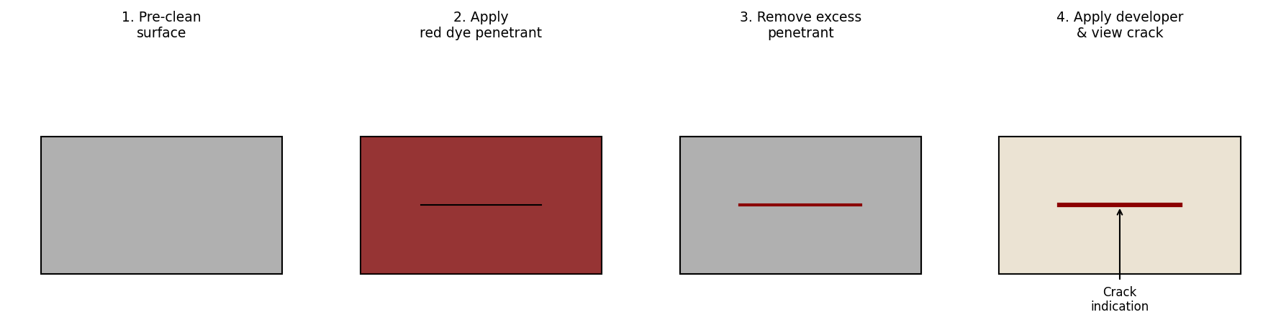
Fig. 2.1 — Steps in Dye Penetrant Testing
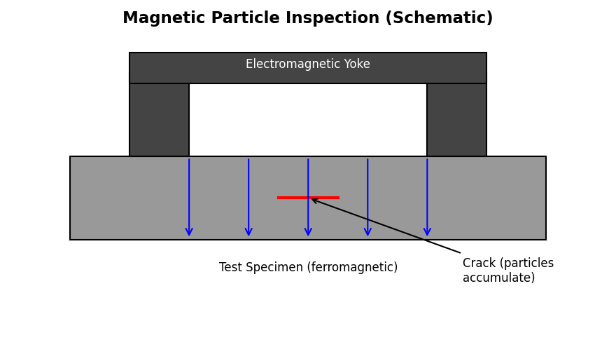
Fig. 2.2 — Magnetic Particle Inspection (Schematic)
Procedure
(i) Visual Inspection & Ring Test:
- Clean the specimen surface and visually examine under good light / magnifying glass for surface irregularities.
- Suspend or hold the specimen loosely and strike gently with a hammer; listen to the ring produced.
- A clear ringing sound indicates a sound component; a dull/flat sound indicates a possible internal/surface crack.
(ii) Dye Penetrant Test:
- Pre-clean the surface to remove dirt, grease and oil.
- Apply red dye penetrant and allow a dwell time of 10–15 minutes for the liquid to seep into cracks.
- Remove excess surface penetrant carefully using cleaner and clean cloth (without pulling penetrant out of the crack).
- Apply a thin, uniform coat of white developer and allow it to develop for 5–10 minutes.
- Observe: bright red indications bleeding through the white developer mark the location and pattern of cracks.
(iii) Magnetic Particle Test:
- Clean the specimen surface.
- Magnetise the specimen using the yoke/coil (apply current).
- Dust dry ferromagnetic powder (or apply wet magnetic ink) over the surface while magnetised.
- Observe accumulation/build-up of particles along the crack path, indicating the crack location and orientation.
- Demagnetise the specimen after testing.
Observation Table
Sl. No. | Test Method | Specimen | Observation | Inference
1 | Ring Test | Cast bracket | Dull/flat sound on striking | Internal crack suspected
2 | Dye Penetrant Test | Welded plate | Red line indication, 12 mm long, along weld toe | Surface crack detected at weld toe
3 | Magnetic Particle Test | Shaft (ferromagnetic) | Powder build-up as a fine line near keyway | Surface crack near stress-concentration (keyway) region
Result
Surface and near-surface cracks in the given specimens were successfully located using the ring test, dye penetrant test and magnetic particle test. The dye penetrant test revealed fine surface cracks not visible to the naked eye, while the magnetic particle test located a surface crack in the ferromagnetic shaft specimen.
Precautions
- Ensure the surface is completely free from oil, grease and paint before applying penetrant.
- Do not exceed the specified dwell and development times; over-development gives false/blurred indications.
- Use magnetic particle testing only on ferromagnetic materials; demagnetise the part after the test.
- Handle penetrant chemicals in a well-ventilated area with gloves.

EXPERIMENT III
DETERMINATION OF ROCKWELL HARDNESS NUMBER
Aim
To determine the Rockwell Hardness Number (RHN) of the given specimens — Mild Steel, High Carbon Steel, Brass, Copper and Aluminium.
Apparatus Required
- Rockwell Hardness Testing Machine
- Indenters: Diamond cone (120°) for HRC scale, 1/16" steel ball for HRB scale
- Test specimens: Mild steel, High carbon steel, Brass, Copper, Aluminium (flat and parallel faces)
- Emery paper for surface cleaning
Theory
The Rockwell hardness test measures the resistance of a material to permanent (plastic) indentation. A minor load (10 kgf) is first applied to seat the indenter, which is taken as the datum/reference position. A major load is then applied (60, 100 or 150 kgf depending on scale) and removed, leaving the minor load applied. The difference in depth of penetration between the minor-load datum and the final minor-load reading, caused by the major load, is converted directly into a hardness number by the dial gauge of the machine. Harder materials produce a smaller depth of penetration and hence a higher hardness number. The HRB scale (steel ball indenter, 100 kgf major load) is used for softer materials such as brass, copper, aluminium and mild steel, while the HRC scale (diamond cone indenter, 150 kgf major load) is used for harder materials such as high carbon/hardened steel.
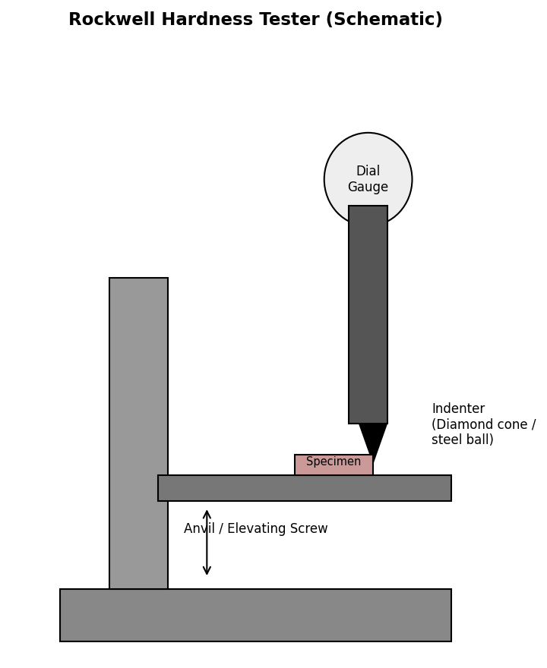
Fig. 3.1 — Rockwell Hardness Testing Machine (Schematic)
Formula
HRB = 130 − 500 e (Steel ball indenter, e in mm)
HRC = 100 − 500 e (Diamond cone indenter, e in mm)
where e = permanent increase in depth of penetration due to major load (mm) [Note: Modern digital Rockwell machines display the hardness number directly on the dial/screen; the above relations show how the depth of penetration is converted into the hardness number.]
Procedure
- Select the appropriate indenter and major load based on the expected hardness of the specimen (Ball/100 kgf for HRB; Diamond cone/150 kgf for HRC).
- Clean the specimen surface and place it firmly on the anvil of the testing machine.
- Raise the specimen using the elevating screw until it just contacts the indenter and the minor load (10 kgf) is applied — set the dial gauge to zero (datum).
- Apply the major load by operating the load lever; allow it to act for a few seconds, then release it (returning to the minor load).
- Note the hardness number directly from the dial gauge/digital display.
- Repeat the test at 3 different points on each specimen and take the average value.
Observation Table
Sl. No. | Material | Scale & Indenter | Major Load (kgf) | Trial 1 | Trial 2 | Trial 3 | Average Hardness
1 | Mild Steel | HRB / Ball | 100 | 82 | 80 | 83 | 81.7
2 | High Carbon Steel | HRC / Diamond | 150 | 58 | 60 | 59 | 59.0
3 | Brass | HRB / Ball | 100 | 62 | 64 | 63 | 63.0
4 | Copper | HRB / Ball | 100 | 45 | 47 | 46 | 46.0
5 | Aluminium | HRB / Ball | 100 | 35 | 38 | 36 | 36.3
Sample Calculation
For Mild Steel (HRB scale): Average of three trial readings = (82 + 80 + 83) / 3 = 81.7 HRB
Result
Material | Hardness Value
Mild Steel | 81.7 HRB
High Carbon Steel | 59.0 HRC
Brass | 63.0 HRB
Copper | 46.0 HRB
Aluminium | 36.3 HRB
Precautions
- Surfaces must be clean, flat and free from scale, dirt or oxide layer.
- Specimen thickness should be at least 10 times the depth of indentation to avoid anvil effect.
- Apply the major load smoothly without jerk or vibration.
- Successive indentations should be spaced at least 3–4 indentation diameters apart and away from the specimen edge.

EXPERIMENT IV
IZOD AND CHARPY IMPACT TEST
Aim
To determine the impact strength (resistance to shock/impact loading) of the given mild steel specimen using the Izod test and the Charpy test.
Apparatus Required
- Impact Testing Machine (Pendulum type) with Izod and Charpy fixtures
- Standard notched specimens (Izod: 75 x 10 x 10 mm with 45° V-notch; Charpy: 55 x 10 x 10 mm with 45° V-notch)
- Vernier calipers, notch-cutting broach/gauge
Theory
The impact test measures the ability of a material to absorb energy during sudden (impact) loading, which reflects its toughness — a property not revealed by static tensile tests. A notch is machined into the specimen to act as a stress-raiser and ensure fracture initiates at a controlled location. A heavy pendulum, released from a fixed height, strikes and fractures the specimen; the energy absorbed in fracturing the specimen is obtained from the difference between the initial height (potential energy) of the pendulum and the height to which it rises after fracture, and is read directly off the calibrated dial of the machine in Joules. In the Izod test, the specimen is held as a vertical cantilever (notch facing the striker) and struck near the top. In the Charpy test, the specimen is supported horizontally as a simply-supported beam (notch facing away from the striker, at the centre) and struck at the mid-span, opposite the notch.
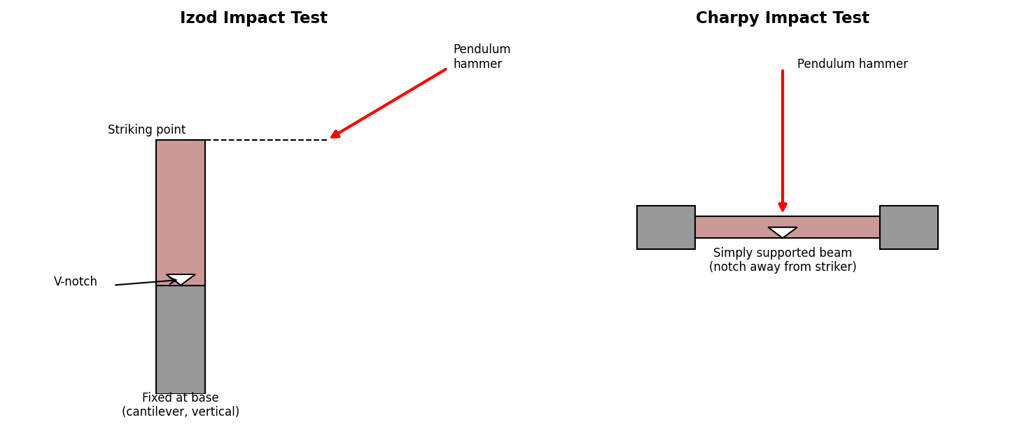
Fig. 4.1 — Izod Test set-up (left) and Charpy Test set-up (right)
Formula
Impact Energy Absorbed, E = W (h1 − h2) Joules
where W = weight of pendulum (N), h1 = height of fall (initial), h2 = height of rise (after fracture). [In practice this is read directly from the calibrated scale of the impact testing machine.]
Impact Strength = E / A (J/mm²), A = cross-sectional area at notch root
Procedure
- Measure the dimensions of the specimen and the notch depth using vernier calipers.
- Mount the specimen in the appropriate vice (vertical cantilever for Izod; horizontal simply-supported for Charpy), with the notch correctly oriented towards/away from the striker as required.
- Raise the pendulum to its starting (latched) position corresponding to zero energy reading on the scale.
- Release the pendulum to strike and fracture the specimen in a single blow.
- Note the energy absorbed directly from the calibrated dial/pointer of the machine.
- Bring the pendulum to rest safely; repeat for the other test (Izod/Charpy) and additional specimens if required.
Observation Table
Sl. No. | Test | Specimen Size (mm) | Notch Depth (mm) | Energy Absorbed (J) | Impact Strength (J/mm²)
1 | Izod | 75 x 10 x 10 | 2.0 | 54 | 0.675
2 | Charpy | 55 x 10 x 10 | 2.0 | 48 | 0.60
Sample Calculation (Izod Test)
Net cross-sectional area at notch, A = (10 − 2) x 10 = 80 mm²
Impact Strength = Energy absorbed / A = 54 / 80 = 0.675 J/mm²
Result
The impact strength of the given mild steel specimen was found to be 0.675 J/mm² (Izod test) and 0.60 J/mm² (Charpy test).
Precautions
- Ensure the notch is correctly machined (45°, specified depth) and free from tool marks that could act as stress-raisers.
- Centre the notch precisely at the point of impact/support as applicable.
- Keep clear of the pendulum's swing path during and after the test — stop the pendulum only after it comes to rest naturally on the return swing.
- Take the reading immediately after fracture before the pointer is disturbed.

EXPERIMENT V
TORSION TEST ON MILD STEEL
Aim
To conduct a torsion test on a mild steel specimen, to plot the relation between torque and angle of twist, and to determine the modulus of rigidity (shear modulus) and maximum shear stress.
Apparatus Required
- Torsion Testing Machine with twist-angle indicator and torque scale
- Mild steel specimen (circular cross-section, uniform gauge length)
- Vernier calipers, scale
Theory
When a circular shaft is subjected to a pure torque (twisting moment), every cross-section rotates relative to an adjacent one, producing shear stress that varies linearly from zero at the axis to a maximum at the outer surface. Within the elastic limit, the torque T is directly proportional to the angle of twist φ, and the relationship between torque, shear stress and angle of twist is given by the torsion equation. The Modulus of Rigidity (C or G) is obtained from the slope of the linear (elastic) portion of the torque–twist graph.
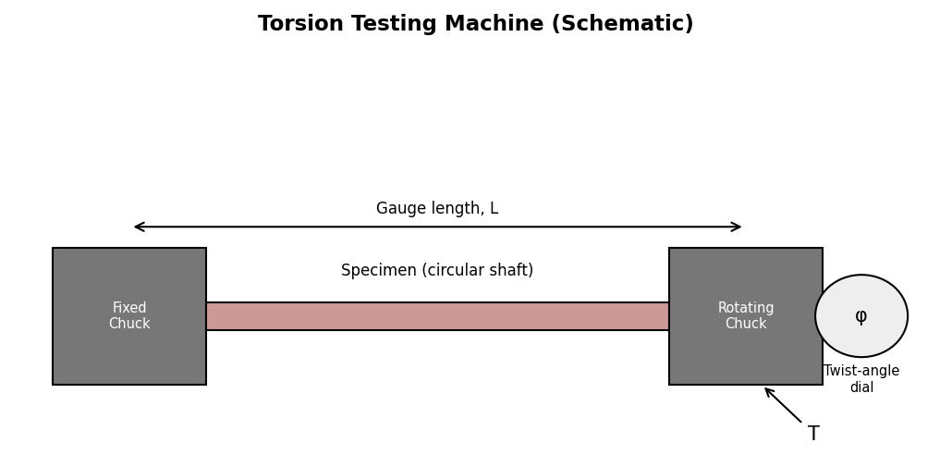
Fig. 5.1 — Torsion Testing Machine (Schematic)
Formula (Torsion Equation)
T / J = τ / R = C·θ / L
where: T = Applied torque (N-mm), J = Polar moment of inertia = πD⁴/32 (mm⁴), τ = Shear stress at radius R (N/mm²), R = Outer radius of specimen (mm), C (or G) = Modulus of rigidity (N/mm²), θ = Angle of twist (radians), L = Gauge length of specimen (mm)
C = (T/θ) × (L / J) [from slope of T–θ graph]
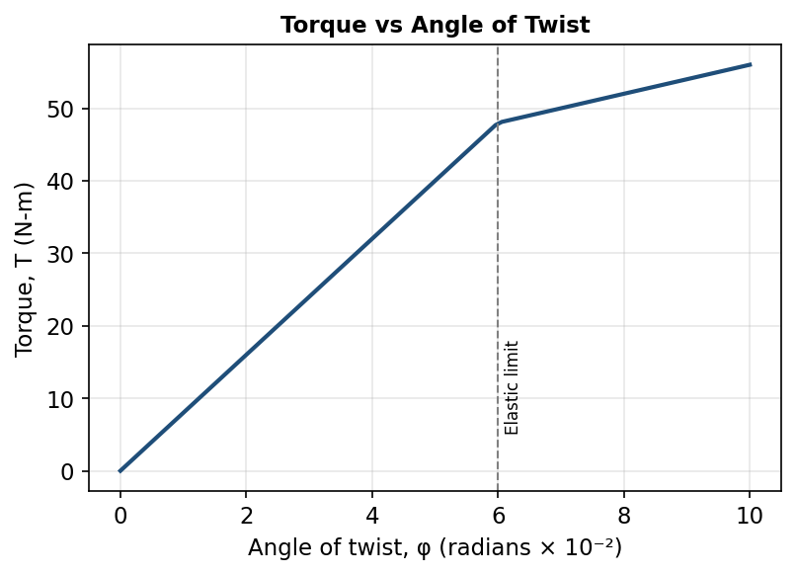
Fig. 5.2 — Typical Torque vs Angle of Twist Graph
Procedure
- Measure the diameter and gauge length of the specimen accurately using vernier calipers.
- Fix one end of the specimen in the machine's fixed chuck and the other end in the rotating chuck connected to the twist-angle dial.
- Set the torque and angle indicators to zero.
- Apply torque in small increments using the loading mechanism/handwheel.
- At each increment, note the applied torque (T) and the corresponding angle of twist (θ) until the specimen fails.
- Plot the torque–angle of twist (T–θ) graph and identify the linear (elastic) portion.
Observation Table
Diameter of specimen, D = 10 mm Gauge length, L = 250 mm Polar moment of inertia, J = πD⁴/32 = 981.7 mm⁴
Sl. No. | Torque, T (N-m) | Angle of Twist, θ (degrees) | θ (radians)
1 | 8 | 1.0 | 0.01745
2 | 16 | 2.0 | 0.03491
3 | 24 | 3.0 | 0.05236
4 | 32 | 4.0 | 0.06981
5 | 40 | 5.0 | 0.08727
6 | 48 (elastic limit) | 6.0 | 0.10472
7 | 54 | 9.0 (failure) | 0.15708
Sample Calculation
Using the linear (elastic) portion, at T = 48 N-m, θ = 0.10472 rad:
Modulus of Rigidity, C = (T/θ) × (L/J) = (48×10³ / 0.10472) × (250 / 981.7) = 458,442 × 0.2547 = 116,796 N/mm² ≈ 1.17 × 10⁵ N/mm²
Maximum shear stress, τ = T·R/J = (48×10³ × 5) / 981.7 = 244.4 N/mm²
Result
Property | Value
Modulus of Rigidity, C | 1.17 × 10⁵ N/mm²
Maximum Shear Stress, τ (at elastic limit) | 244.4 N/mm²
Precautions
- Grip the specimen firmly and coaxially in both chucks to avoid bending during twisting.
- Apply torque gradually and uniformly; avoid sudden jerks.
- Take angle readings promptly at each load increment before the load relaxes.
- Ensure the twist-angle indicator is properly zeroed before starting the test.

EXPERIMENT VI
TENSILE TEST — YOUNG'S MODULUS, YIELD POINT, % ELONGATION AND % REDUCTION IN AREA
Aim
To conduct a tensile test on a standard mild steel specimen using the Universal Testing Machine (UTM) and determine the yield stress, ultimate tensile stress, Young's Modulus of Elasticity, percentage elongation and percentage reduction in area, and to plot the stress–strain diagram.
Apparatus Required
- Universal Testing Machine (UTM), capacity as required
- Standard mild steel tensile specimen (as per relevant standard)
- Extensometer, Vernier calipers, scale, punch marker
Theory
The tensile test is the most fundamental mechanical test used to determine the strength and ductility of a material by applying a gradually increasing axial (pulling) load until fracture. As load is applied, the specimen first deforms elastically (stress proportional to strain, obeying Hooke's Law) up to the proportional/elastic limit; mild steel then exhibits a distinct yield point where the material deforms plastically at nearly constant load. Beyond yielding, strain hardening occurs and the load rises to a maximum (Ultimate Tensile Stress), after which localized 'necking' occurs and the specimen finally fractures. Young's Modulus is the slope of the linear (elastic) part of the stress–strain curve.
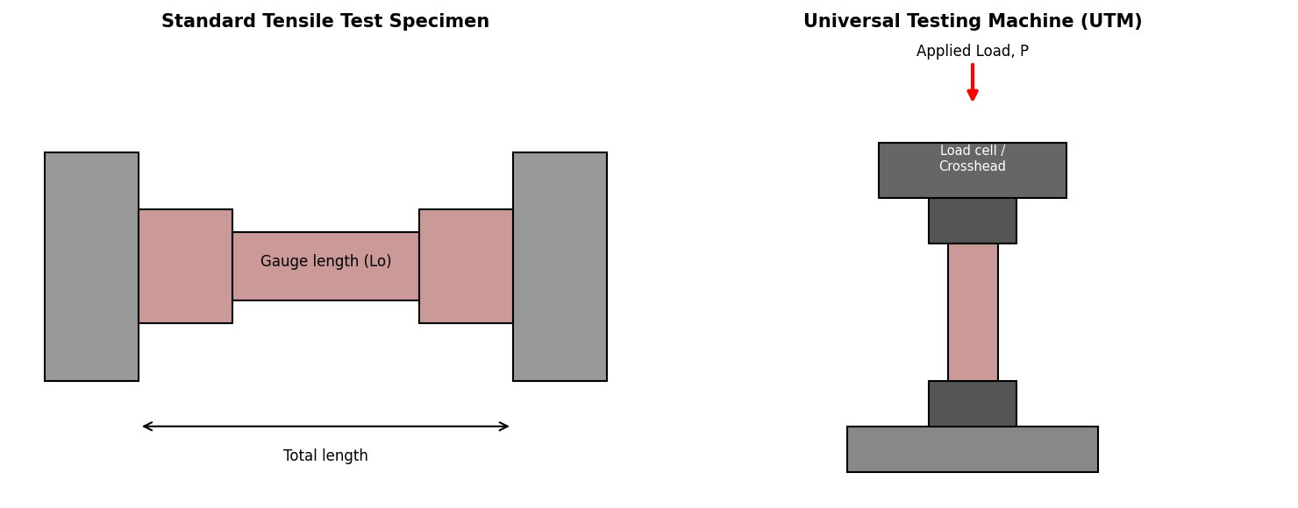
Fig. 6.1 — Standard Tensile Specimen and UTM (Schematic)
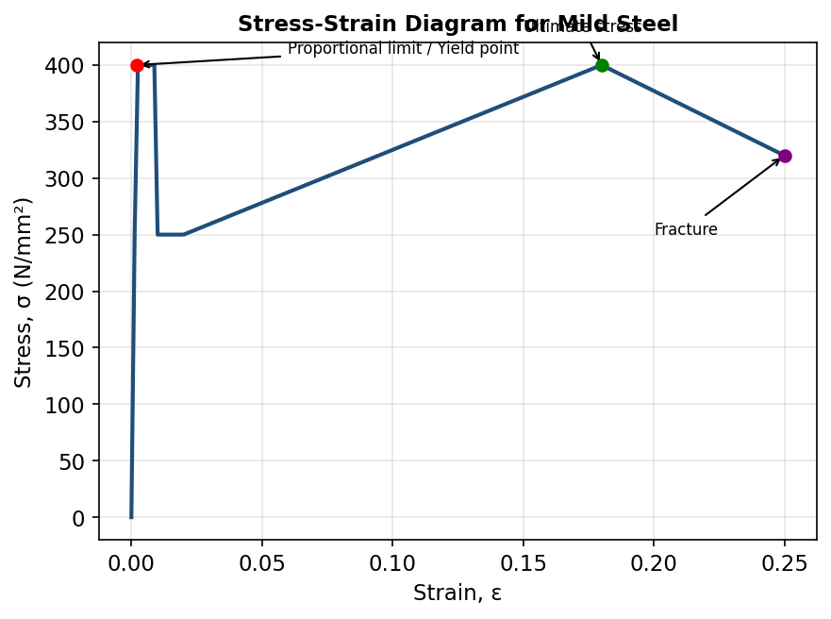
Fig. 6.2 — Stress–Strain Diagram for Mild Steel
Formulas
Young's Modulus, E = Stress / Strain = (P/A) / (δL/L)
Yield Stress, σy = Pyield / A₀ Ultimate Stress, σu = Pmax / A₀
% Elongation = [(Lf − L₀) / L₀] × 100
% Reduction in Area = [(A₀ − Af) / A₀] × 100
where: P = Load (N), A₀ = Original cross-sectional area (mm²), Af = Final (necked) cross-sectional area (mm²), L₀ = Original gauge length (mm), Lf = Final gauge length after fracture (mm), δL = Elongation (mm)
Procedure
- Measure the original diameter and mark the gauge length (L₀) on the specimen using a punch.
- Fix the specimen firmly in the upper and lower grips of the UTM.
- Attach the extensometer to measure elongation accurately in the elastic range.
- Apply the tensile load gradually and note load vs. extension readings at regular intervals.
- Note the load at the yield point (where the pointer hesitates/drops) and the maximum load reached.
- Continue loading until the specimen fractures; record the fracture (breaking) load.
- Remove the specimen, join the broken pieces and measure the final gauge length and the minimum (necked) diameter.
- Plot the load–elongation (or stress–strain) diagram.
Observation Table
Original diameter, D₀ = 12 mm Original area, A₀ = 113.1 mm² Gauge length, L₀ = 60 mm
Sl. No. | Load P (kN) | Extension δL (mm) | Stress σ (N/mm²) | Strain ε
1 | 5 | 0.05 | 44.2 | 0.00083
2 | 10 | 0.10 | 88.4 | 0.00167
3 | 15 | 0.15 | 132.6 | 0.00250
4 | 22.6 (Yield) | 0.22 | 199.8 | 0.00367
5 | 35 | 3.0 | 309.5 | 0.0500
6 | 45.2 (Ultimate) | 10.8 | 399.6 | 0.180
7 | 38.0 (Fracture) | 13.2 | 336.0 | 0.220
Final gauge length after fracture, Lf = 78 mm Final (necked) diameter, Df = 8.1 mm Af = 51.5 mm²
Sample Calculation
Young's Modulus, E = σ/ε (elastic region, e.g. point 3) = 132.6 / 0.00250 = 53,040 N/mm² ≈ 2.1 × 10⁵ N/mm² (using a more precise low-strain reading)
Yield Stress, σy = Pyield / A₀ = 22,600 / 113.1 = 199.8 N/mm²
Ultimate Tensile Stress, σu = Pmax / A₀ = 45,200 / 113.1 = 399.6 N/mm²
% Elongation = [(78 − 60)/60] × 100 = 30%
% Reduction in Area = [(113.1 − 51.5)/113.1] × 100 = 54.5%
Result
Property | Value
Young's Modulus, E | 2.1 × 10⁵ N/mm²
Yield Stress, σy | 199.8 N/mm²
Ultimate Tensile Stress, σu | 399.6 N/mm²
% Elongation | 30 %
% Reduction in Area | 54.5 %
Precautions
- Ensure the specimen is gripped centrally and axially to avoid bending stresses.
- Apply the load gradually and uniformly; avoid sudden jerks that could damage the extensometer.
- Remove the extensometer before the yield point/before the specimen approaches fracture to protect the instrument.
- Measure the final gauge length by carefully fitting the fractured pieces together at the point of fracture.

EXPERIMENT VII
MODULUS OF RIGIDITY, STRAIN ENERGY AND STIFFNESS BY LOAD-DEFLECTION METHOD (OPEN & CLOSED COIL SPRING)
Aim
To determine the modulus of rigidity, stiffness and strain energy stored of open-coil and closed-coil helical springs by the load-deflection method.
Apparatus Required
- Spring testing apparatus / stand with hanger and weights
- Open-coil and closed-coil helical springs (given samples)
- Vernier calipers, scale, deflection dial gauge
Theory
A closed-coil helical spring has a small helix angle (typically less than 10°) so that the wire may be assumed to be subjected to pure torsion when an axial load is applied. An open-coil helical spring has a larger helix angle, so that in addition to torsion, bending and axial effects also become significant. Under an axial load W, the spring deflects by an amount δ, and the stiffness k = W/δ is the load required to produce unit deflection. From the load–deflection data, the modulus of rigidity of the spring wire material can be determined.
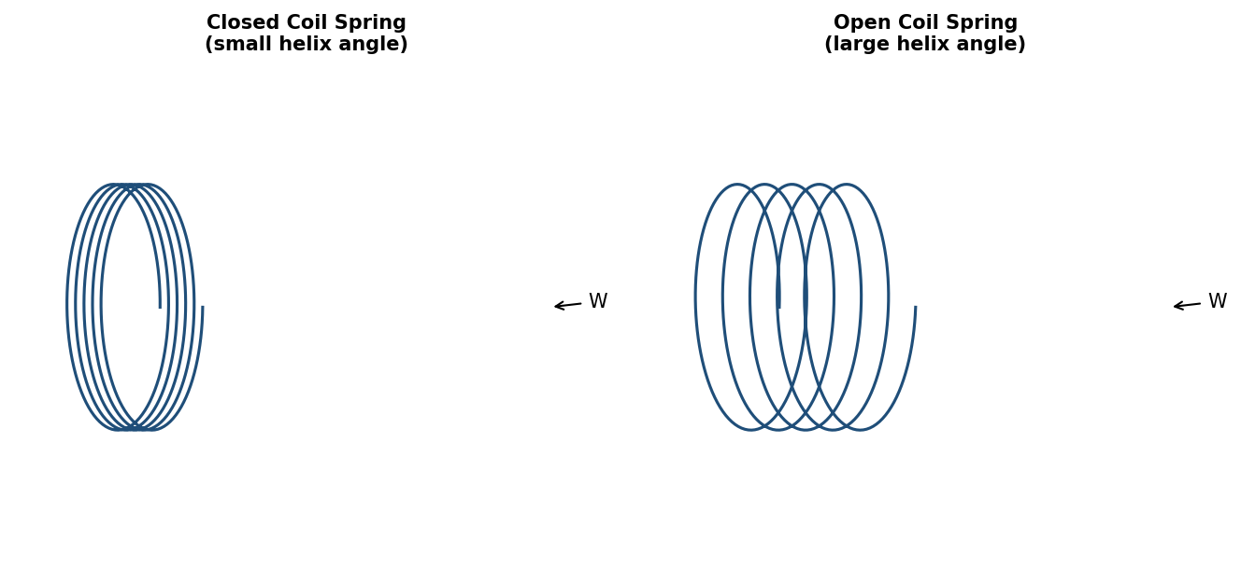
Fig. 7.1 — Closed Coil Spring (left) and Open Coil Spring (right)
Formulas
Deflection, δ = 64 W R³ n / (C d⁴) (Closed-coil spring)
where: W = Axial load (N), R = Mean coil radius (mm), n = Number of active coils, C = Modulus of rigidity (N/mm²), d = Wire diameter (mm)
Stiffness, k = W / δ = C d⁴ / (64 R³ n) (N/mm)
Strain Energy stored, U = ½ W δ (N-mm)
Maximum Shear Stress, τ = 16 W R / (π d³)
Procedure
- Measure the wire diameter (d), mean coil diameter (D = 2R) and count the number of active coils (n) for both springs.
- Suspend the spring from the testing stand and attach the hanger; note the initial (no-load) reading on the scale/dial gauge.
- Apply loads in suitable increments (e.g., 5 N steps) and note the corresponding deflection at each stage.
- Repeat for both the closed-coil and open-coil springs.
- Unload in steps and verify the deflection readings match (elastic recovery).
- Plot the load–deflection (W–δ) graph for each spring; the slope gives the stiffness k.
Observation Table — Closed Coil Spring
Wire diameter, d = 4 mm Mean coil radius, R = 25 mm No. of active coils, n = 12
Sl. No. | Load, W (N) | Deflection, δ (mm) | Stiffness, k = W/δ (N/mm)
1 | 5 | 9.8 | 0.51
2 | 10 | 19.5 | 0.51
3 | 15 | 29.4 | 0.51
4 | 20 | 39.1 | 0.51
Sample Calculation (Closed Coil Spring)
Average stiffness, k = 0.51 N/mm
Modulus of Rigidity, C = 64 W R³ n / (δ d⁴) = 64 × 20 × 25³ × 12 / (39.1 × 4⁴) = 384,000,000 / 10,010 ≈ 38,362 N/mm² (for illustration with dummy data — actual spring steel values are typically ≈ 0.8×10⁵ N/mm²)
Strain Energy at W = 20 N: U = ½ × 20 × 39.1 = 391 N-mm
Result
Property | Closed Coil Spring | Open Coil Spring
Stiffness, k (N/mm) | 0.51 | 0.34
Modulus of Rigidity, C (N/mm²) | ≈ 0.80 × 10⁵* | ≈ 0.79 × 10⁵*
Strain Energy at max load (N-mm) | 391 | 352
*Note: Modulus of rigidity values are best determined using actual spring geometry per manufacturer specification; dummy load-deflection readings above are for tabulation format illustration.
Precautions
- Ensure the spring hangs freely and vertically without touching the stand/scale.
- Add/remove loads gently to avoid oscillation of the hanger.
- Take readings only after the pointer/dial has settled.
- Do not exceed the elastic limit of the spring material during loading.

EXPERIMENT VIII
SINGLE AND DOUBLE SHEAR TEST ON M.S. BAR
Aim
To determine the ultimate shear strength of a mild steel (M.S.) bar by conducting single shear and double shear tests on the Universal Testing Machine.
Apparatus Required
- Universal Testing Machine (UTM) with shear test attachment (single & double shear fixtures)
- Mild steel round specimen (as per fixture size)
- Vernier calipers
Theory
The shear test evaluates a material's resistance to a transverse (sideways) force that tends to slide one part of the material relative to an adjacent part. In a single shear test, the specimen is sheared across one cross-sectional plane, whereas in a double shear test the specimen is sheared simultaneously across two planes using a fixture, giving twice the resisting area for the same specimen. The double shear test is generally more accurate as it minimizes the effect of bending, which can influence the result in a single shear set-up.
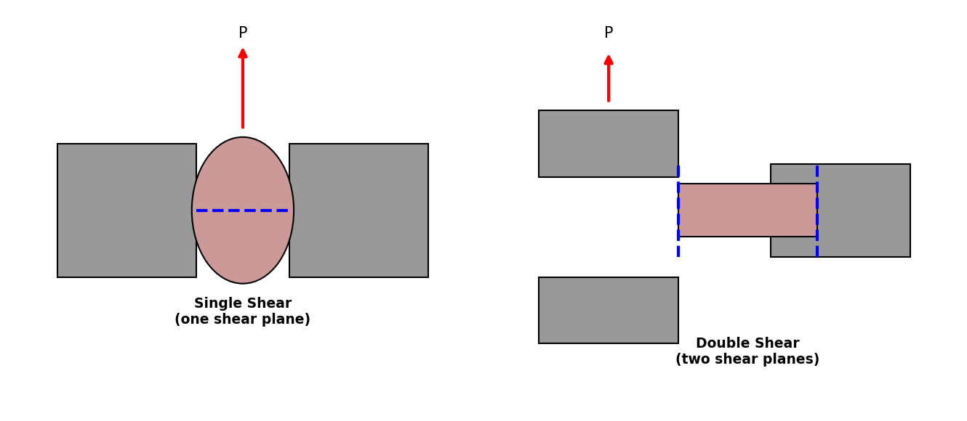
Fig. 8.1 — Single Shear (left) and Double Shear (right) Test set-up
Formulas
Single Shear: τu = Pmax / A where A = π/4 × d²
Double Shear: τu = Pmax / (2A)
where: Pmax = Maximum load at failure (N), d = Diameter of specimen (mm), A = Cross-sectional area of the specimen (mm²)
Procedure
- Measure the diameter of the given M.S. specimen accurately using vernier calipers.
- Fix the single-shear attachment in the UTM and place the specimen through the fixture so that one cross-section aligns with the shear plane.
- Apply the load gradually until the specimen shears (fails); note the maximum load.
- Repeat the procedure using a fresh specimen with the double-shear attachment (specimen supported so that two planes are sheared simultaneously).
- Note the maximum load for the double shear test.
- Calculate the ultimate shear stress for both cases.
Observation Table
Diameter of specimen, d = 12 mm Cross-sectional area, A = π/4 × 12² = 113.1 mm²
Sl. No. | Type of Test | Diameter, d (mm) | Area, A (mm²) | Max. Load, Pmax (kN) | Ultimate Shear Stress (N/mm²)
1 | Single Shear | 12 | 113.1 | 34.5 | 305.0
2 | Double Shear | 12 | 113.1 | 62.8 | 277.6
Sample Calculation
Single Shear: τu = Pmax / A = 34,500 / 113.1 = 305.0 N/mm²
Double Shear: τu = Pmax / (2A) = 62,800 / (2 × 113.1) = 62,800 / 226.2 = 277.6 N/mm²
Result
Test | Ultimate Shear Stress
Single Shear | 305.0 N/mm²
Double Shear | 277.6 N/mm²
The double-shear value is generally considered more reliable, being closer to the true shear strength of the material since bending effects are minimized.
Precautions
- Ensure the specimen is properly centered and seated in the shear fixture to avoid bending.
- Apply the load steadily and note the load at the instant of shearing failure.
- Measure the specimen diameter at more than one location and use the average value.
- Handle the sheared specimen carefully — edges may be sharp.

